**TEST 1 : [10-06-2024]**

1. **Reverse a number**

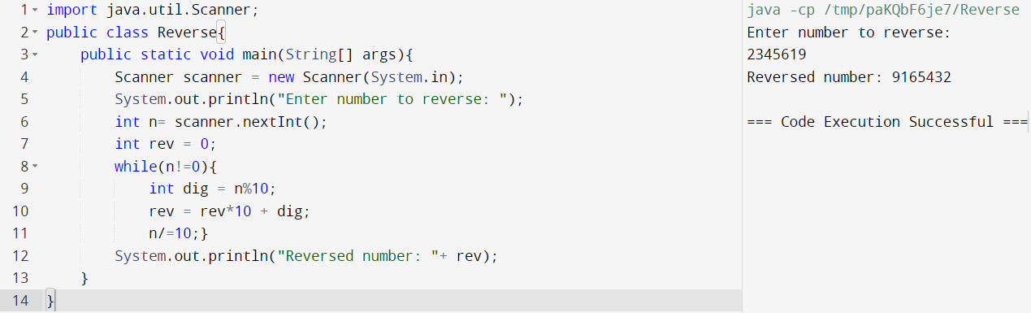

1. **Eligibility to Vote**

